1 FCFS

#include<stdio.h>
#include<stdlib.h>
void swap(int *a,int *b)
{int temp;
temp=*a;
*a=*b;
*b=temp;
}
void main()
{int n,i,j;
float sw=0,st=0;
printf("Enter the number of process:");
scanf("%d",&n);
int *a=(int*)malloc(n*sizeof(int));
int *b=(int*)malloc(n*sizeof(int));
int *w=(int*)malloc(n*sizeof(int));
int *t=(int*)malloc(n*sizeof(int));
for( i=0;i<n;++i)
{printf("Enter the AT of %d :",i+1);
scanf("%d",&a[i]);
//printf("%d",a[i]);
printf("Enter the BT of %d :",i+1);
scanf("%d",&b[i]);
}
for(i=0;i<n-1;++i)
for(j=i+1;j<n;++j)
{if(a[i]>a[j])
{swap(&a[i],&a[j]);
swap(&b[i],&b[j]);
}
}
for( i=0;i<n;++i)
{w[i]=0;
for(j=0;j<i;++j)
w[i]+=b[j];
w[i]=w[i]-a[i]+a[0];
t[i]=w[i]+b[i];
}
printf("Process \t Burst Time \t Arrival Time \t Waiting Time \t Turnaround Time\n");
for(i=0;i<n;++i)
{printf("P%d \t \t %d \t \t %d \t \t %d \t \t %d \n",i+1,b[i],a[i],w[i],t[i]);
sw+=w[i];
st+=t[i];}
printf("Average waiting time is %f \nAverage turnaround time is %f \n",sw/n,st/n);
printf("GANT chart\n");
int *pid=(int*)malloc(n*sizeof(int));
int *finish=(int*)malloc(n*sizeof(int));
for(i=0;i<n;++i)
{
pid[i]=i;
finish[i]=a[i]+b[i]+w[i];
}
for(i=0;i<n-1;++i)
for(j=i+1;j<n;++j)
{if(finish[i]>finish[j])
{swap(&finish[i],&finish[j]);
swap(&pid[i],&pid[j]);
}
}
for(i=0;i<n;++i)
{printf("P%d \t",pid[i]+1);
}
printf("\n");
for(i=0;i<n;++i)
{printf("%d \t",finish[i]);
}
printf("\n");

}
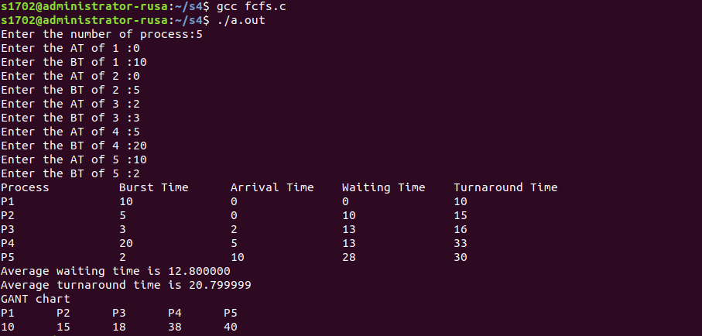

2 SJF

#include<stdio.h>
#include<stdlib.h>
void swap(int *a,int *b)
{int temp;
temp=*a;
*a=*b;
*b=temp;
}
void main()
{int n,i,j;
float sw=0,st=0;
printf("Enter the number of process :");
scanf("%d",&n);
int *a=(int*)malloc(sizeof(int));
int *b=(int*)malloc(sizeof(int));
int *w=(int*)malloc(sizeof(int));
int *t=(int*)malloc(sizeof(int));
for( i=0;i<n;++i)
{//printf("Enter the AT of %d \n",i+1);
//scanf("%d",&a[i]);
//printf("%d",a[i]);
printf("Enter the BT of %d :",i+1);
scanf("%d",&b[i]);
}
for(i=0;i<n-1;++i)
for(j=i+1;j<n;++j)
{if(b[i]>b[j])
{swap(&b[i],&b[j]);
}
}
for( i=0;i<n;++i)
{w[i]=0;
for(j=0;j<i;++j)
w[i]+=b[j];
t[i]=w[i]+b[i];
}
printf("Process \t Burst Time \t Waiting Time \t Turnaround Time\n");
for(i=0;i<n;++i)
{printf("P%d \t \t %d \t \t %d \t \t %d \n",i+1,b[i],w[i],t[i]);
sw+=w[i];
st+=t[i];}
printf("Average waiting time is %f \nAverage turnaround time is %f \n",sw/n,st/n);
printf("GANT chart\n");
int *pid=(int*)malloc(n*sizeof(int));
int *finish=(int*)malloc(n*sizeof(int));
for(i=0;i<n;++i)
{
pid[i]=i;
finish[i]=b[i]+w[i];
}
for(i=0;i<n-1;++i)
for(j=i+1;j<n;++j)
{if(finish[i]>finish[j])
{swap(&finish[i],&finish[j]);
swap(&pid[i],&pid[j]);
}
}
for(i=0;i<n;++i)
{printf("P%d \t",pid[i]+1);
}
printf("\n");
for(i=0;i<n;++i)
{printf("%d \t",finish[i]);
}
printf("\n");
}

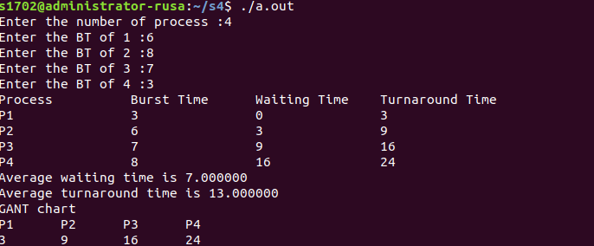

3 PRIORITY

#include<stdio.h>
#include<stdlib.h>
void swap(int *a,int *b)
{int temp;
temp=*a;
*a=*b;
*b=temp;
}
void main()
{int n,i,j;
float sw=0,st=0;
printf("Enter the number of process\n");
scanf("%d",&n);
int *a=(int*)malloc(sizeof(int));
int *b=(int*)malloc(sizeof(int));
int *w=(int*)malloc(sizeof(int));
int *t=(int*)malloc(sizeof(int));
for( i=0;i<n;++i)
{printf("Enter the Priority of %d :",i+1);
scanf("%d",&a[i]);
//printf("%d",a[i]);
printf("Enter the BT of %d :",i+1);
scanf("%d",&b[i]);
}
for(i=0;i<n-1;++i)
for(j=i+1;j<n;++j)
{if(a[i]>a[j])
{swap(&a[i],&a[j]);
swap(&b[i],&b[j]);
}
}
for( i=0;i<n;++i)
{w[i]=0;
for(j=0;j<i;++j)
w[i]+=b[j];
t[i]=w[i]+b[i];
}
printf("Process \t Burst Time \t Priority \t Waiting Time \t Turnaround Time\n");
for(i=0;i<n;++i)
{printf("P%d \t \t %d \t \t %d \t \t %d \t \t %d \n",i+1,b[i],a[i],w[i],t[i]);
sw+=w[i];
st+=t[i];}
printf("Average waiting time is %f \nAverage turnaround time is %f \n",sw/n,st/n);
printf("GANT chart\n");
int *pid=(int*)malloc(n*sizeof(int));
int *finish=(int*)malloc(n*sizeof(int));
for(i=0;i<n;++i)
{
pid[i]=i;
finish[i]=b[i]+w[i];
}
for(i=0;i<n-1;++i)
for(j=i+1;j<n;++j)
{if(finish[i]>finish[j])
{swap(&finish[i],&finish[j]);
swap(&pid[i],&pid[j]);
}
}
for(i=0;i<n;++i)
{printf("P%d \t",pid[i]+1);
}
printf("\n");
for(i=0;i<n;++i)
{printf("%d \t",finish[i]);
}
printf("\n");
}

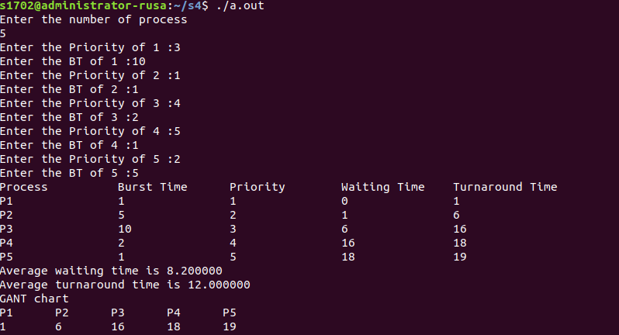

4 Round Robin

#include<stdio.h>
#include<stdlib.h>
#include<string.h>
void swap(int *a,int *b)
{int temp;
temp=*a;
*a=*b;
*b=temp;
}
void main()
{int n,i,j,tq,temp,null=0;
float sw=0,st=0;
printf("Enter the number of process\n");
scanf("%d",&n);
printf("Enter time quantum\n");
scanf("%d",&tq);
int *remb=(int*)malloc(n*sizeof(int));
int *b=(int*)malloc(n*sizeof(int));
int *w=(int*)malloc(n*sizeof(int));
int *t=(int*)malloc(n*sizeof(int));
for( i=0;i<n;++i)
{//printf("Enter the AT of %d :",i+1);
//scanf("%d",&a[i]);
//printf("%d",a[i]);
printf("Enter the BT of %d :",i+1);
scanf("%d",&b[i]);
}
for(i=0;i<n;++i)
{
//printf("%d\n",b[i]);
remb[i]=b[i];
}

memset (w, 0, sizeof (int) * n);
do
for(i=0;i<n;++i)
{null=0;
if(remb[i]==0)
continue;
else if(remb[i] >= tq)
{printf("P%d |",i+1);
remb[i]=remb[i]-tq;
for(j=0;j<n;++j)
{
if(remb[j]!=0 && j!=i)
w[j]=w[j]+tq;
}
}
else
{printf("P%d |",i+1);
temp=remb[i];
remb[i]=0;
for(j=0;j<n;++j)
{
if(remb[j]!=0 && j!=i)
w[j]=w[j]+temp;
}

}
for(j=0;j<n;++j)
if(remb[j]!=0)
{
null=1;
break;
}
}
while(null);
printf("\n");
for(i=0;i<n;++i)
{t[i]=w[i]+b[i];
}
printf("Process \t Burst Time \t Waiting Time \t Turnaround Time\n");
for(i=0;i<n;++i)
{printf("P%d \t \t %d \t \t %d \t \t %d \n",i+1,b[i],w[i],t[i]);
sw+=w[i];
st+=t[i];}
printf("Average waiting time is %f \n Average turnaround time is %f \n",sw/n,st/n);

}

